Eric Rouse

Individual Assignments #58

Assignment: Section 2.1: 6, 8, 12, 16, 18, 28

# Q6

1. No
2. No
3. Yes
4. Yes
5. Yes
6. Yes

# Q8

1. T
2. T
3. T
4. T
5. T
6. F
7. F

# Q12

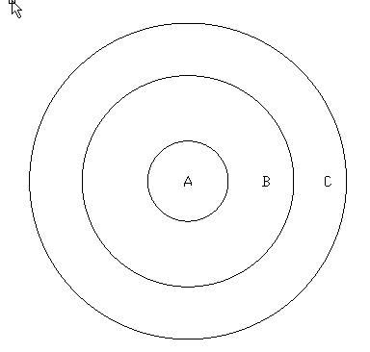

# Q16

Set 1: A = {1} & B = {{1},2}

Set2: A = {x,y} & B = {z,12,m,{x,y}}

# Q18

1. 0
2. 1
3. 2
4. 3

# Q28

1. {(a,x,0),(a,x,1),(a,y,0),(a,y,1), (b,x,0),(b,x,1),(b,y,0),(b,y,1), (c,x,0),(c,x,1),(c,y,0),(c,y,1)}
2. {(0,x,a),(0,x,b),(0,x,c),(0,y,a),(0,y,b),(0,y,c), (1,x,a),(1,x,b),(1,x,c),(1,y,a),(1,y,b),(1,y,c)}
3. {(0,a,x),(0,a,y),(0,b,x),(0,b,y),(0,c,x),(0,c,y), (1,a,x),(1,a,y),(1,b,x),(1,b,y),(1,c,x),(1,c,y)}
4. {(x,x,x),(x,x,y),(x,y,x),(x,y,y),(y,x,x),(y,x,y),(y,y,x),(y,y,y)}